Jonathan Yang

Assignment 2

Birthday Class

**Test Case 3**

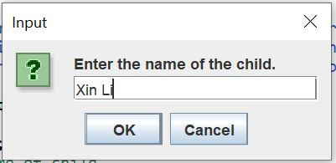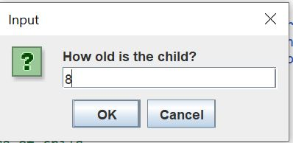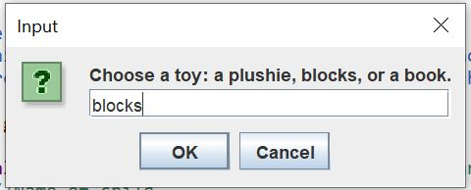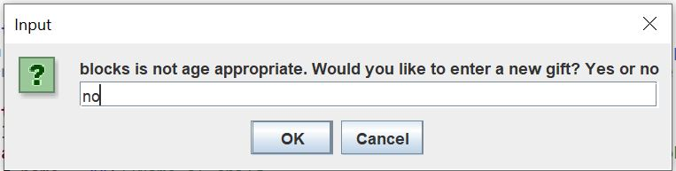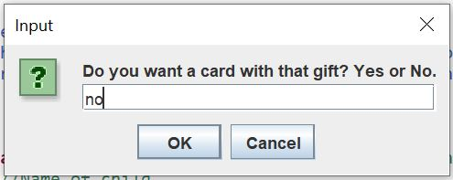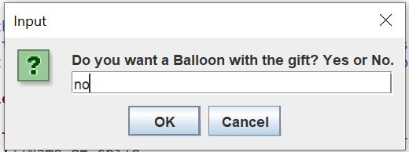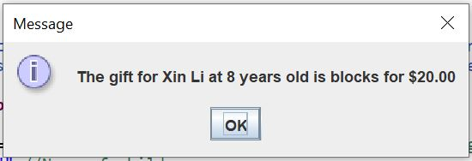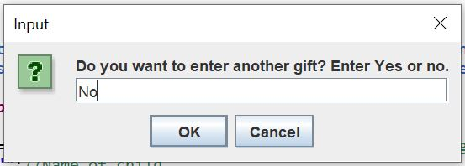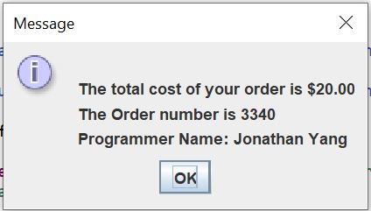

|  |  |  |  |  |  |
| --- | --- | --- | --- | --- | --- |
| Test Case # | Input | Actual Input | Expected Output | Actual Output | Did the test pass? |
| 3 | Name:  Xin Li  Age:  8  Toy:  Blocks  Cards:  No  Balloon:  No | Name:  Xin Li  Age:  8  Toy:  Blocks  Cards:  No  Balloon:  No | Age Ok:  No  Total Cost:  20.00 | Age Ok:  No  Total Cost:  20.00 | Yes |